Project Description:

|  |  |
| --- | --- |
|  | **Segmentation  Missing pills** |

This project is about segmentation Missing pills to find the missing pills result after we create suitable code.

By using:

**Pill segmentation** that falls into the domain of image segmentation

**Image segmentation** is defined as a branch of digital image processing which focuses on partitioning an image into different parts according to their features and properties.

The primary goal of image segmentation is to simplify the image for easier analysis.

In image segmentation, you divide an image into various parts that have similar attributes.

The parts in which you divide the image are called Image Objects.

**Segmentation should stop when objects of interest in the image are isolated**

There is a lot of research already done in the field leading to numerous

image segmentation techniques. These techniques will be explored in this problem “project”

* Region based methods: based on discontinuities.
* Edge/Boundary based methods: based on similarity.
* Hybrid methods: a combination of methods from the previous groups.

**Region based methods**

are methods that divide the entire image into sub

regions or clusters based on discontinuities between pixels. They work well

when a region homogeneity criterion is easy to define.

**Threshold-based**

is the process of replacing the pixels in an image with either blacks or whites.

Threshold-based techniques are generally used to turn a grey

scaled image into a binary image consisting of a background and a foreground.

The foreground is defined as the objects of interest and the background as the remaining pixels.

As the name implies threshold-based methods rely on a threshold to segment the image.

This threshold can be hand-picked, or a suitable threshold can be determined automatically.

An advantage of threshold-based segmentation over

the other techniques is it's speed. The main disadvantage is the difficulties

in determining the right threshold.

**Hybrid methods**

takes advantage of both region based and edge based methods.

And uses a combination to successfully segment an image.

Our method falls in this category, as do all methods we found

pill-shaped object segmentation.

Flowchart outlining the method used

Project Steps:

* Find topic name
* Trying to create suitable code to run
* Turned the picture from RGB2GRAY
* create the right code for this case
* Find the result

Code Steps:

1. close all;
2. clear all;
3. i= imread('im2.jpg');
4. imshow(i);
5. g=rgb2gray(i);
6. figure;
7. imshow(g);
8. imhist (g);
9. bw=g>130;

10.imshow(bw);

11.se=strel('disk',7);

12.afterOpening=imopen(bw,se);

13.imshow(afterOpening);

14.[L,num]=bwlabel(afterOpening,4);

15.display(15-num);

**Why we turn the picture from RGB to Grayscale (or Graylevel) image?**

The reason for differentiating such images from any other sort of color image is **that less information needs to be provided for each pixel.**

**in Matlab?**

The rgb2gray function converts RGB images to grayscale **by eliminating the hue and saturation information while retaining the luminance**.

**What is BW = im2bw(I , level ) description:**

Means Convert image to binary image, based on threshold

by replacing all pixels in the input image with luminance greater than level with the value 1 (white) and replacing all other pixels with the value 0 (black).

Code function description:

* close all;
* clear all;
* This steps used when we want to delete the old output
* i= imread('im2.jpg’);
* To read the picture
* imshow(i);
* To show the picture
* g=rgb2gray(i);
* To turned the picture form RGB to Gray
* imshow(g);
* To show the picture into gray
* imhist (g);
* To find histogram to turned picture into bw
* bw=g>130;
* Turned picture into bw
* imshow(bw);
* To show the picture into bw
* se=strel('disk',7);
* to present the shape of the pills
* afterOpening=imopen(bw,se);
* Open the bw picture after se
* imshow(afterOpening);
* Show bw picture after se
* [L,num]=bwlabel(afterOpening,4);
* Covered the desk to all of the picture
* display(15-num);
* 15 the number of total pills, num the number of the pills on the picture

Results in gray

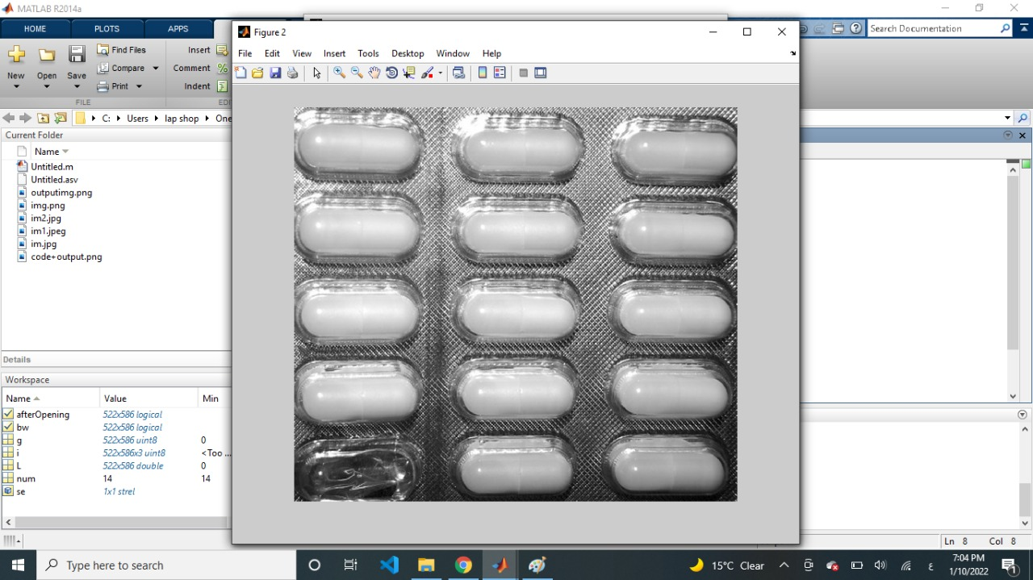

Histogram

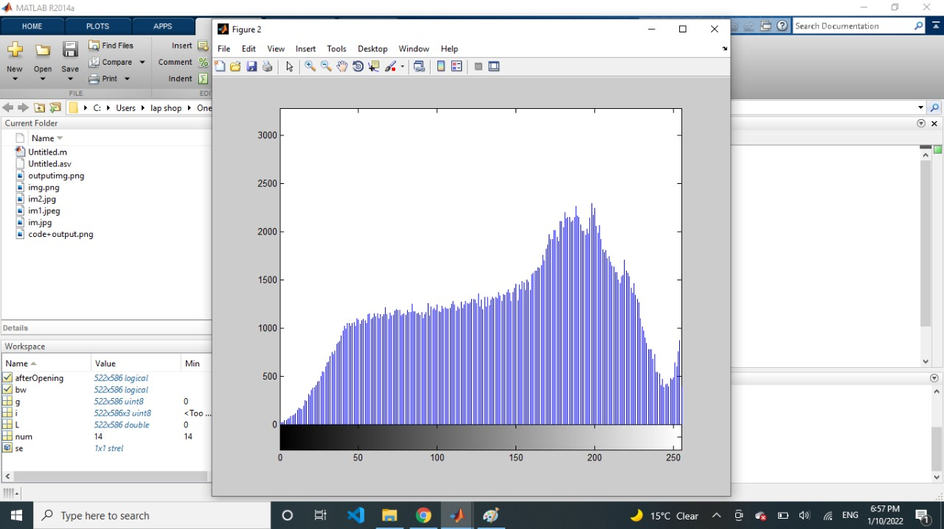

Results in BW

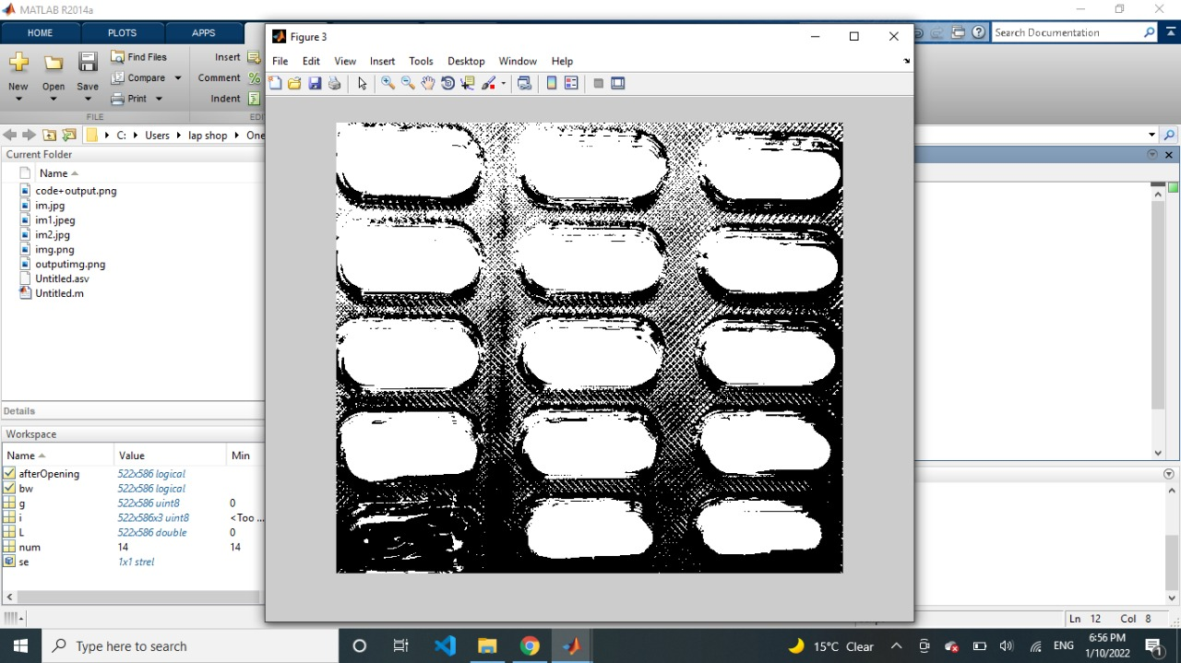

**Conclusion**

Image segmentation is a big part of computer vision, and it's used in a lot of different businesses. Image segmentation is used by facial recognition technology in your phone & advanced security systems to recognize your face. A traffic system can recognize a car and obtain information about its owner using number plate identification technologies. Image segmentation algorithms are used by Google and other image-based search engines to recognize the items in your picture and compare their conclusions with the relevant photos they discover to provide you with search results. We employ image segmentation in the medical field to find and identify cancer cells, quantify tissue volumes, conduct virtual surgery simulations, and navigate during operation. **And as in our project detect and identify the missing pills**. And by getting familiar with Image segmentation methods, you will get an idea of where you should use one and where you should avoid using the other.